**SCIENTIFIC CALCULATOR**

21CSC101T

OBJECT ORIENTED DESIGN AND PROGRAMMING

**Mini Project Report**

*Submitted by*

**Student Name:-KUNDAN KUMAR MISHRA**

**[Reg. No.: RA2211003010542]**

**Student Name :-AYUSH KUMAR MISHRA**

**[Reg. No.: RA2211003010547]**

***Under the Guidance of***

**Dr .Muralidharan.C**

**Assistant proffesor,Computing Technology**

## **BACHELOR OF TECHNOLOGY**

**in**

**COMPUTER SCIENCE ENGINEERING**

**with specialization in CSE CORE.**



**SCHOOL OF COMPUTING**

**COLLEGE OF ENGINEERING AND TECHNOLOGY**

**SRM INSTITUTE OF SCIENCE AND TECHNOLOGY**

**(Under Section 3 of UGC Act, 1956)**

S.R.M. NAGAR, KATTANKULATHUR – 603 203

KANCHEEPURAM DISTRICT

MAY 2023

**BONAFIDE CERTIFICATE**

This is to certify that 21CSC101T - Object Oriented Design and Programming mini project report titled “SCIENTIFIC CALCULATOR” is the bonafide work of KUNDAN KUMAR MISHRA(RA2211003010542) AYUSH KUMAR MISHRA(RA2211003010547) who undertook the task of completing the project within the allotted time.

| **SIGNATURE**  Dr. Muralidharan.C  **OODP – Course Faculty**  **Assistant professor**  Department of computing Technology  SRMIST | **SIGNATURE**  Dr.M.Pushpalatha  Professor & Head Department of Computing Technologies School of Computing  SRMIST |
| --- | --- |

**TABLE OF CONTENTS**

|  |  |  |
| --- | --- | --- |
| **S.No** | **CONTENTS** | **PAGE NO** |
| 1. | Problem Statement | **4** |
| 2. | Modules of Project | **5** |
| 3. | Diagrams |  |
|  | 1. Use case Diagram | **6** |
|  | 1. Class Diagram | **7** |
|  | 1. Sequence Diagram | **8** |
|  | 1. Collaboration Diagram | **9** |
|  | 1. State Chart Diagram | **10** |
|  | 1. Activity Diagram | **11** |
|  | 1. Package Diagram | **12** |
|  | 1. Component Diagram | **13** |
|  | 1. Deployment Diagram | **14** |
| 4. | Code/Output Screenshots | **15-21** |
| 5. | Conclusion and Results | **22,23** |
| 6. | References | **24** |

Chapter 1

PROBLEM STATEMENT:-

Enter 1 for Addition

Enter 2 for Subtraction

Enter 3 for Multiplication

Enter 4 for Division

Enter 5 for Power

Enter 6 for Factorial

Enter 7 for square

Enter 8 for cube

Enter 9 for squareroot

Enter you choice:-

Chapter 2

MODULES OF A PROJECT:-

A scientific calculator includes a range of mathematical functions, including basic arithmetic operations (addition, subtraction, multiplication, division) as well as logarithmic functions and exponential functions and many more has been included

Chapter 3

UML diagrams

3.a.Use case diagram for scientific calculator

CALCULATOR SYSTEM

USER

CHECK STATUS

ENTER VALUES

TAKE OUTPUT

Fig 1. Use case diagram

3.b.Class diagram for scientific calculator

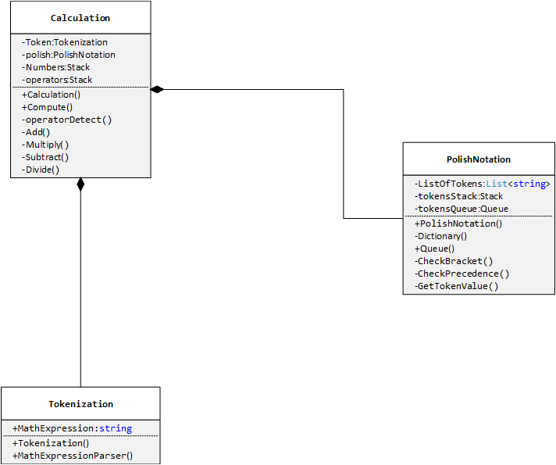

Fig.2.class diagram

3.c.Component diagram for scientific calculator

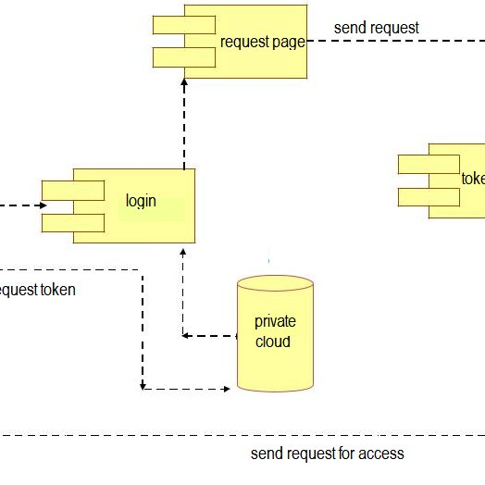

Fig.3.Component diagram

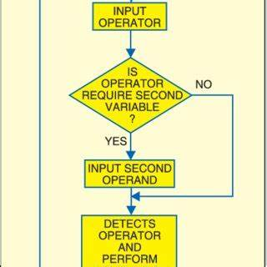3.d..Activitty diagram for scientific calculator

START

:-

Fig.4.activity

diagram

3.e.Sequence diagram for scientific calculator

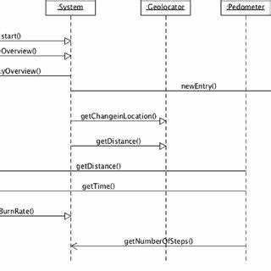

Fig: - 5. Sequence diagram

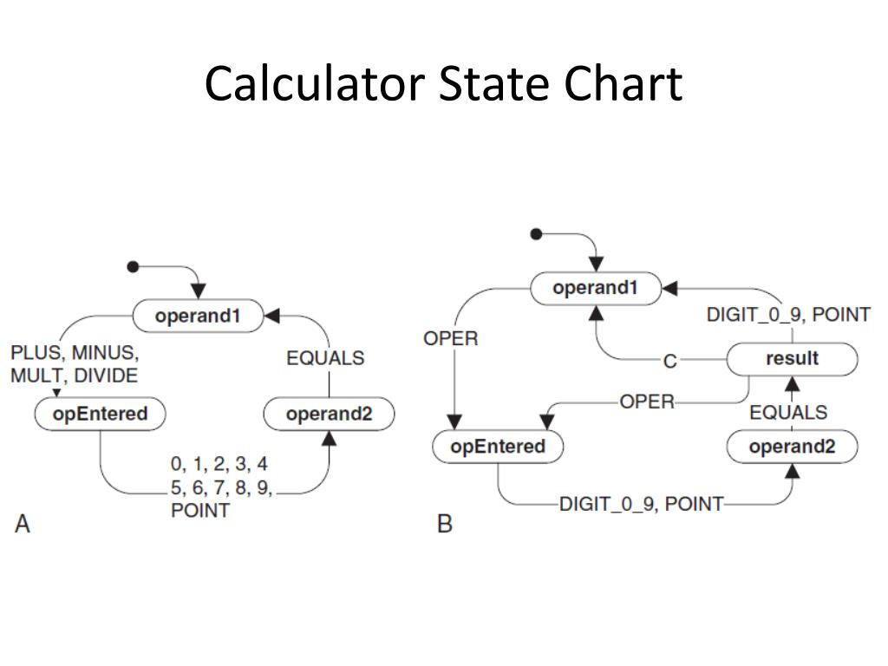

3.f. State chart diagram for scientific calculator

Fig: - 6. State chart diagram

3.g.Deployment diagram for scientific calculator:-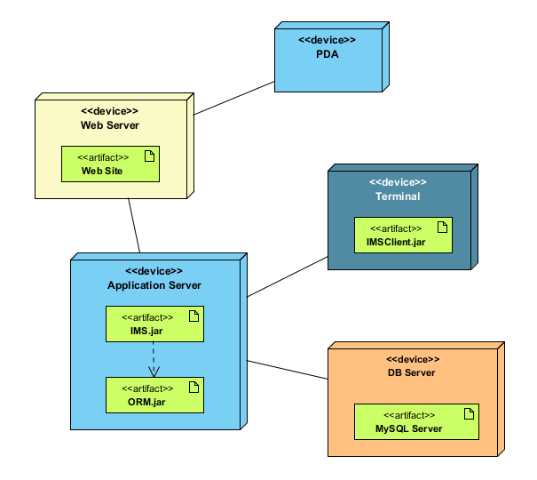

OUTPUT FROM THE SYSTEM

AUTHENTICATION

INPUT FROM USER

START PROCESSING

ENTER THE SYSTEM

Fig: - 7. Deployment diagram

3.h..Package diagram for scientific calculator

C++ <double>

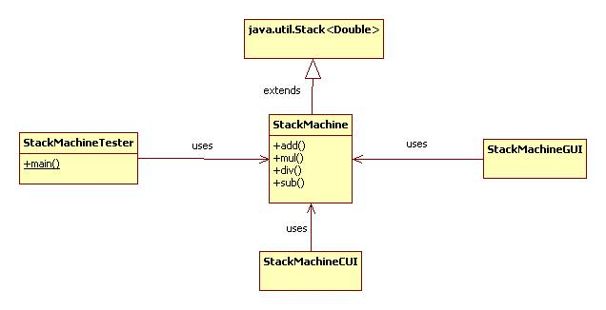

Fig: - 8. Package diagram

C++ code

#include <iostream>

#include <cstdlib>

#include <cmath>

using namespace std;

void addition();

void subtraction();

void multiplication();

void division();

void factorial();

void power();

void square();

void cube();

void squareroot();

int main()

{

cout << "\t\tWelcome to the scientific Calculator, developed by Kundan and Ayush !!\n"

<< endl;

cout << "*******Press 0 to quit the program*******\n"

<< endl;

cout << "Enter 1 for Addition \n";

cout << "Enter 2 for Subtraction \n";

cout << "Enter 3 for Multiplication \n";

cout << "Enter 4 for Division \n";

cout << "Enter 5 for Power \n";

cout << "Enter 6 for Factorial \n";

cout << "Enter 7 for square \n";

cout << "Enter 8 for cube \n";

cout << "Enter 9 for squareroot\n\n";

int choice;

while (1)

{

cout << "Enter you choice: ";

cin >> choice;

switch (choice)

{

case 1:

addition();

break;

case 2:

subtraction();

break;

case 3:

multiplication();

break;

case 4:

division();

break;

case 5:

power();

break;

case 6:

factorial();

break;

case 7:

square();

break;

case 8:

cube();

break;

case 9:

squareroot();

break;

case 0:

exit(0);

break;

default:

cout << "\n*******Wrong choice, Enter valid choice*******\n\n";

break;

}

}

return 0;

}

void addition()

{

cout << "Enter the numbers you want to add: ";

int a, b;

cin >> a >> b;

cout << "The addition of " << a << " and " << b << " is " << a + b << endl;

}

void subtraction()

{

cout << "Enter the numbers you want to subtract: ";

int a, b;

cin >> a >> b;

cout << "The subtraction of " << a << " and " << b << " is " << a - b << endl;

}

void multiplication()

{

cout << "Enter the numbers you want to multipliation: ";

int a, b;

cin >> a >> b;

cout << "The multiplication of " << a << " and " << b << " is " << a * b << endl;

}

void division()

{

cout << "Enter the numbers you want to divide: ";

int a, b;

cin >> a >> b;

cout << "The division of " << a << " and " << b << " is " << (float)a / (float)b << endl;

}

void factorial()

{

cout << "Enter the number you want the factorial of: ";

int n;

cin >> n;

int fact = 1;

for (int i = 1; i <= n; i++)

{

fact = fact * i;

}

cout << "The factorial of " << n << " is " << fact << endl;

}

void power()

{

cout << "Enter the base and exponent: ";

double b, e;

cin >> b >> e;

double power = pow(b, e);

cout << "The solution for base " << b << " and exponent " << e << " is " << power << endl;

}

void square()

{

cout << "Enter the number you want the sqaure of: ";

double b;

cin >> b;

double power = pow(b, 2);

cout << "The square of " << b << " is " << power << endl;

}

void cube()

{

cout << "Enter the number you want the cube of: ";

double b;

cin >> b;

double power = pow(b, 3);

cout << "The cube of " << b << " is " << power << endl;

}

void squareroot()

{

cout << "Enter the number you want the square root of: ";

double n;

cin >> n;

double squareRoot = sqrt(n);

cout << "The Square root of " << n << " is " << squareRoot << endl;

}

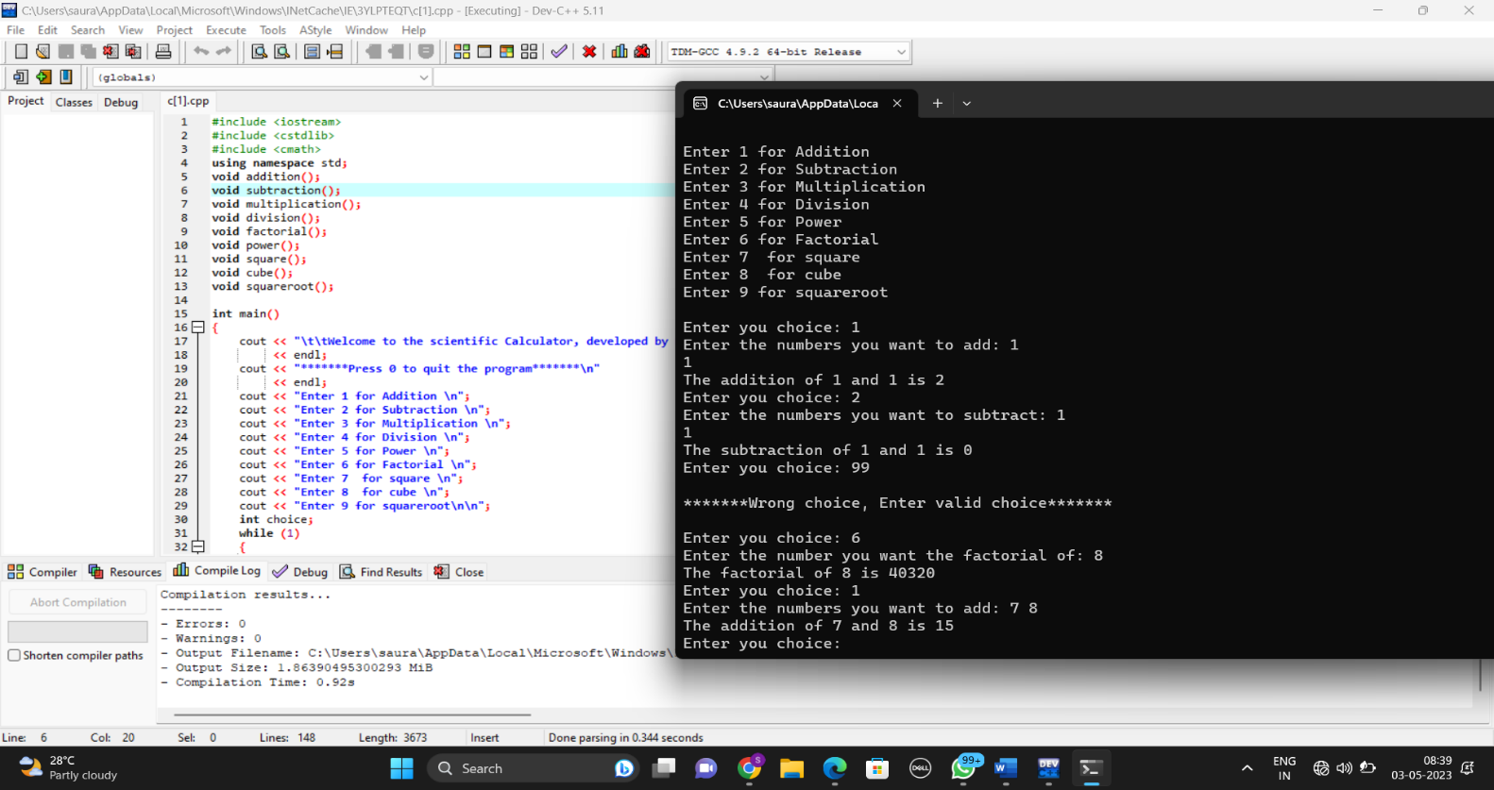OUTPUT SCREENSHOT:-

CONCLUSION AND RESULT-

By doing this mini project , We have learnt how to create a scientific calculator using c++ language.

It helps to calculate basic mathematical operations .

And atlast we can calculate as we desire.

REFERENCE:-

●Object oriented programming with c++ by E Balagurusamy(https://logicwork.in/pdf-download-object-oriented-programming-with-c-by-e-balagurusamy-book-pdf/)

●https://www.w3schools.com/cpp/cpp_